SESSION 1 – Introduction to Databases & Installation

  - Task 1: Install MySQL Community Server on your computer and take a screenshot of the MySQL installer completion window.
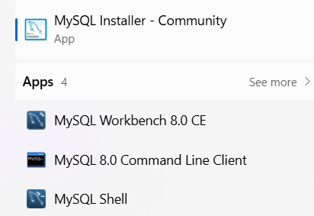

  - 2. Open MySQL Workbench or DB Browser, connect to your local MySQL server, and create a new database called music_streaming_db.
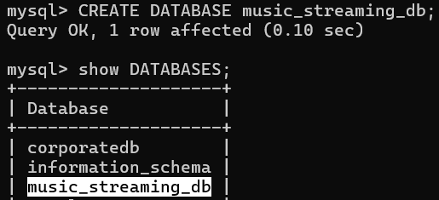

  - 3. Write the SQL command to create a new database named food_delivery_db and execute it in your SQL Workbench or DB Browser.<br><br><em><strong>Hint:</strong> Use the CREATE DATABASE statement.</em>
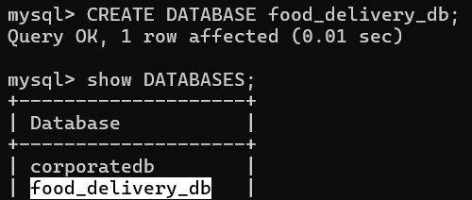

  - 4. List 3 differences between MySQL and PostgreSQL in terms of features or use cases, and give one example of a popular app or company that uses each.
Feature / Use Case | MySQL | PostgreSQL
Performance | Optimized for read-heavy workloads, widely used in web applications | Better for complex queries and write-heavy workloads
Features | Simpler, lightweight, fewer advanced features | Advanced features like full-text search, JSON support, and custom data types
Community & Usage | Very popular in startups and small-to-medium web apps | Preferred in enterprise systems and applications needing complex analytics

One example of a popular app or company that uses each :
- MySQL → Used by Facebook
- PostgreSQL → Used by Instagram

